Learn ಕನ್ನಡ(Kannada) interactively with Sounds By Vedavyasa Rao
By Vedavyasa Rao

Introduction
This tool is designed for the audience such as school going kids or adults interested in learning Kannada language by forming words and later hearing the sounds of the words. The sounds are provided by the courtesy of Googles Text to Speech Synthesizers.
The tool comes with preloaded sounds for vowels and consonants with Kagunita. These are again generated by the courtesy of Googles Text to Speech Synthesizers.
The preloaded sound files are stored and streamed by courtesy of GitHub.
The tool itself is a single HTML page with JavaScript code driving it. Crucial parts of the JavaScript code is generated by the courtesy of Gemini ai.
URL: https://aiaksharamaale.blogspot.com/2026/10/learn-kannada-interactively-with-sounds.html
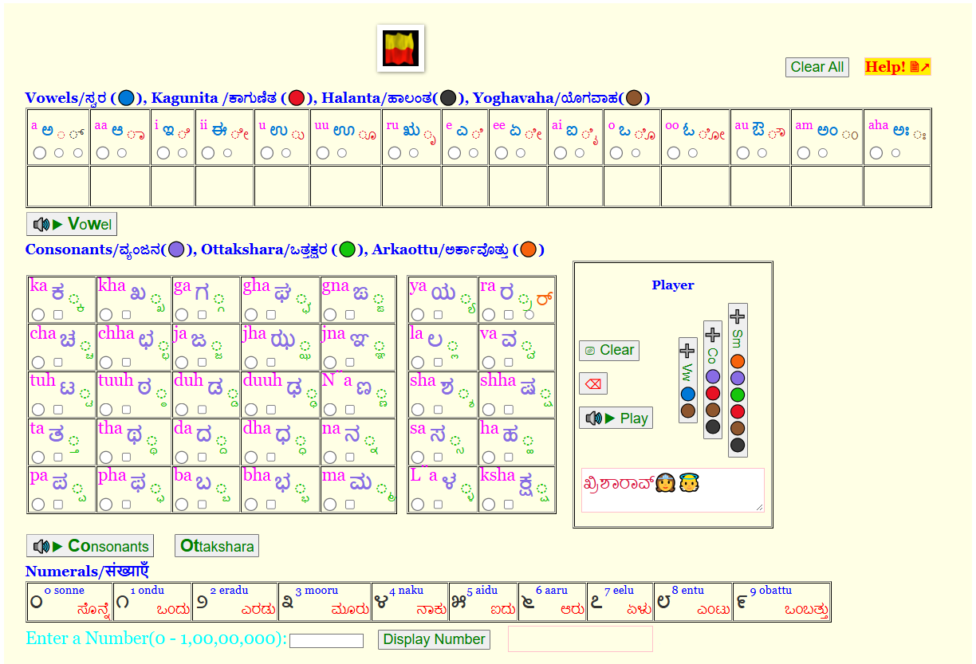

We shall deep dive to understand different aspects of the tool.

Character Groupings
Vowels: ಅ, ಆ, ಇ, ಈ, ಉ, ಊ, ಋ, ಎ, ಏ, ಐ, ಒ, ಓ, ಔ, ಅಂ, ಅಃ
Kagunita: ◌, ಾ, ಿ, ೀ, ು, ೂ, ೃ, ೆ, ೇ, ೈ, ೊ, ೋ, ೌ
Halanta: ्
Yogavaha: ं, ः
Consonants:
ಕ, ಖ, ಗ, ಘ, ಙ,
ಚ, ಛ, ಜ, ಝ, ಞ,
ಟ, ಠ, ಡ, ಢ, ಣ,
ತ, ಥ, ದ, ಧ, ನ,
ಪ, ಫ, ಬ, ಭ, ಮ,
ಯ, ರ, ಲ, ವ, ಶ, ಷ, ಸ, ಹ, ಳ, ಕ್ಷ
Ottakshara:
◌್ಕ ◌್ಖ ◌್ಗ ◌್ಘ ◌್ಙ
◌್ಚ ◌್ಛ ◌್ಜ ◌್ಝ ◌್ಞ
◌್ಟ ◌್ಠ ◌್ಡ ◌್ಢ ◌್ಣ
◌್ತ ◌್ಥ ◌್ದ ◌್ಧ ◌್ನ
◌್ಪ ◌್ಫ ◌್ಬ ◌್ಭ ◌್ಮ
◌್ಯ ◌್ರ ◌್ಲ ◌್ವ ◌್ಶ ◌್ಷ ◌್ಸ ◌್ಹ ◌್ಳ ◌್ಕ್ಷ
Arakaouttu
ರ್

Radio button mappings

Vowels, Matras, Halant and Ayogavaha
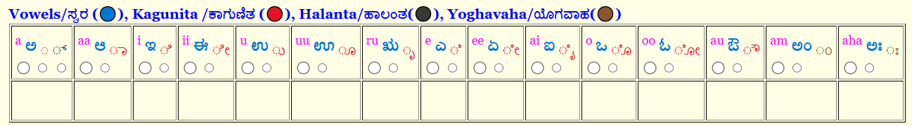

Vowels Kagunita Halant Ayogavaha
(Anusvara, Visarga)

Consonants, Ottakshara and Arkaottu
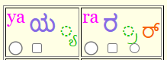

Consonant Ottakshara Arkaottu
Notice that the radio buttons have matching colors as the text.
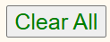
Clicking this button clears all Radio button selections.

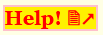
Displays this PDF file.

Player

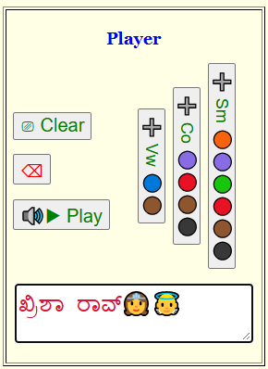
Append a Vowel /With Yogavaha to Play Buffer
Play Sounds for the text in Play Buffer.
Editable Play Buffer
Backspace. Erase last character in the Play Buffer.
Append a Ottakshara, Arkaottu with Marta/ +Ayogavaha and Halant to Play Buffer

Append a Consonant with Kagunita/ +Yogavaha /+Halant to Play Buffer

Clear entire Play Buffer.

Grammar Rules
For Vowels, Vowels (🔵) and Yogavaha (🟤) are allowed. Examples, ಏ, ಉಂ
For Consonants, Consonants (🟣), Kagunita (🔴), Halant (⚫), Yogavaha (🟤) are allowed. Examples, ರಾಮಶಂಕರ್
For Samyuktakshars, Ardha vyanjans (🟢), Consonants(🟣), Ayogavaha (🟤), Halant (⚫), Arkaottu (🟠) and Kagunita (🔴) are allowed. Examples, ಸೂರ್ಯಃ
The player is editable, so you can separate letters by putting comma. This will slow down the playback.
For e.g., ಕ,ಕಾ,ಕಿ,ಕೀ,ಕು,ಕೂ,ಕೃ,ಕೆ,ಕೇ,ಕೈ,ಕೊ,ಕೋ,ಕೌ,ಕಂ,ಕಃ

Numerals
The numbers can be entered into the input box. Clicking the “Display Button” prints the number and populates its Kannada text in the “Play Buffer” for audio sound as shown below.
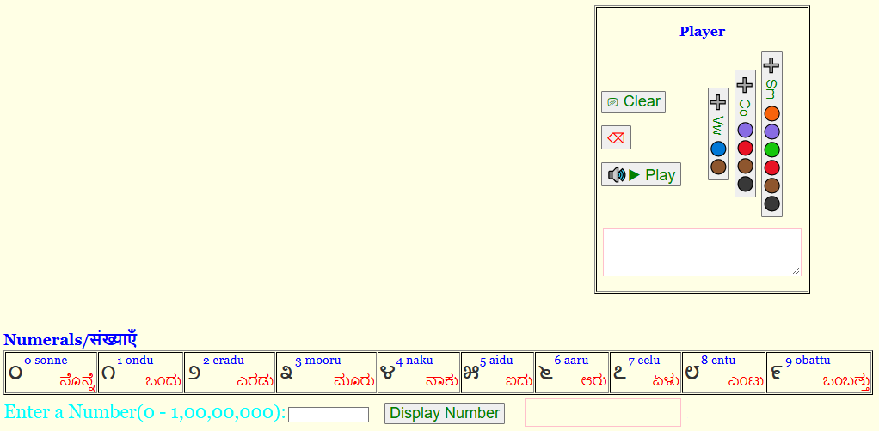
Shows Kannada number text. E.g. Sonne

Shows Kannada number. E.g, ०
Enter a decimal number. E.g, 0

Use cases
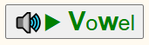
Prints Vowels and Plays associated sound.
✅ Vowels (🔵)
❌ Consonants(🟣)
❌ Ottakshara (🟢)
❌ Arkaottu (🟠)
✅ Yogavaha (🟤)
❌ Kagunita (🔴)
❌ Halant (⚫)

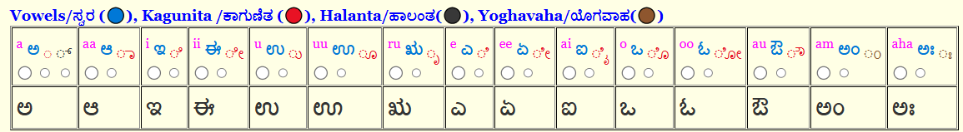
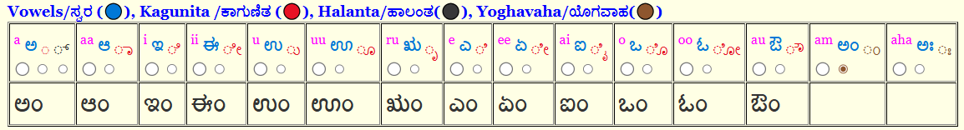
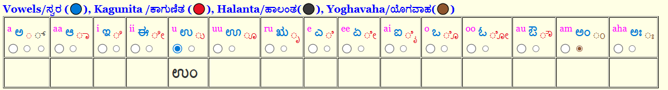

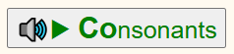
Prints Consonants and Plays associated sound.
❌ Vowels (🔵)
✅ Consonants(🟣)
❌ Ottakshara (🟢)
❌ Arkaottu (🟠)
✅ Yogavaha (🟤)
✅ Kagunita (🔴)
✅ Halant (⚫)

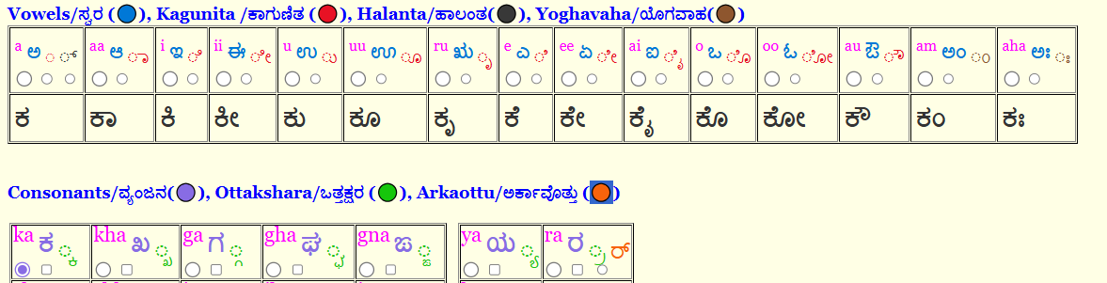
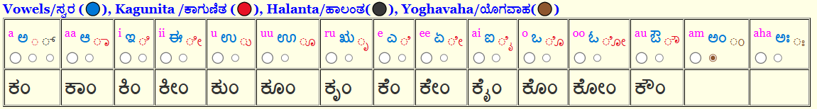
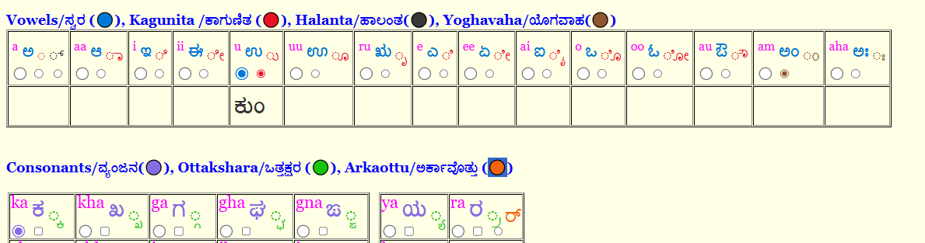

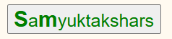
Prints Samyuktakshars only. The sounds can be generated from the player by separating generated text with a comma as shown below.
For e.g., क्र,क्रा,क्रि,क्री,क्रु,क्रू,क्रृ,क्रे,क्रै,क्रो,क्रौ,क्रं,क्रः
❌ Vowels (🔵)
✅ Consonants(🟣)
✅ Ottakshara (🟢)
✅ Arkaottu (🟠)
✅ Yogavaha (🟤)
✅ Kagunita (🔴)
✅ Halant (⚫)

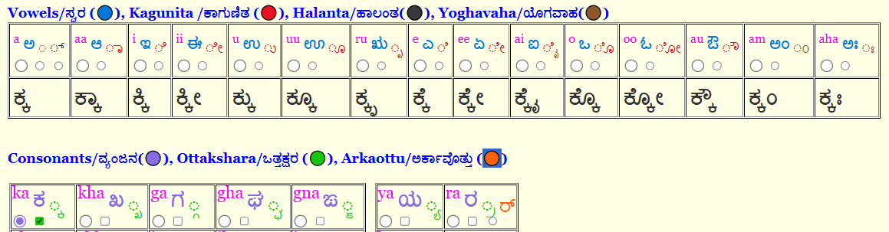
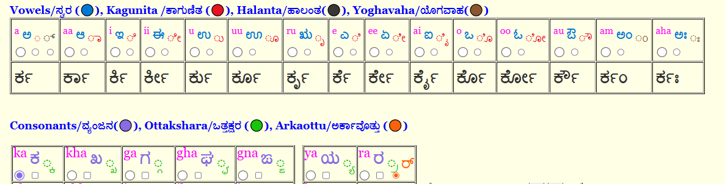
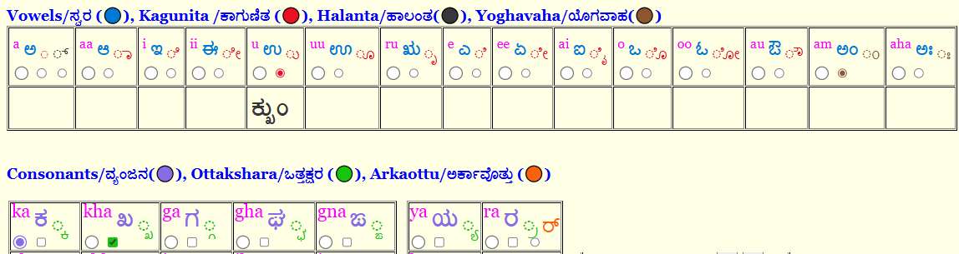

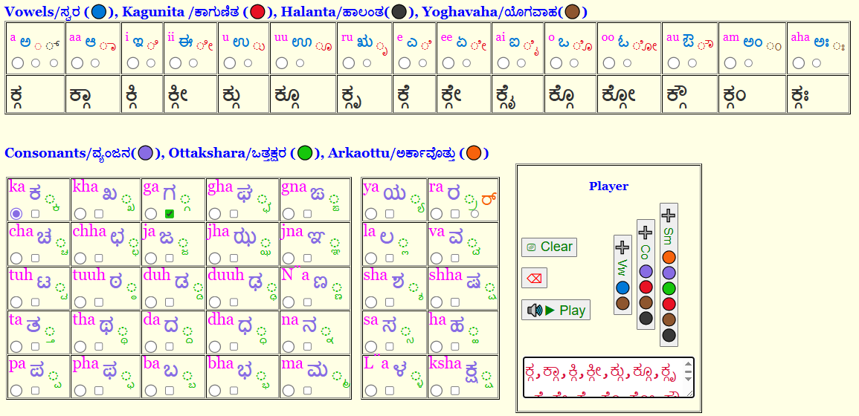

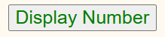
Converts decimal number into Kannada number and kannada text for the same.
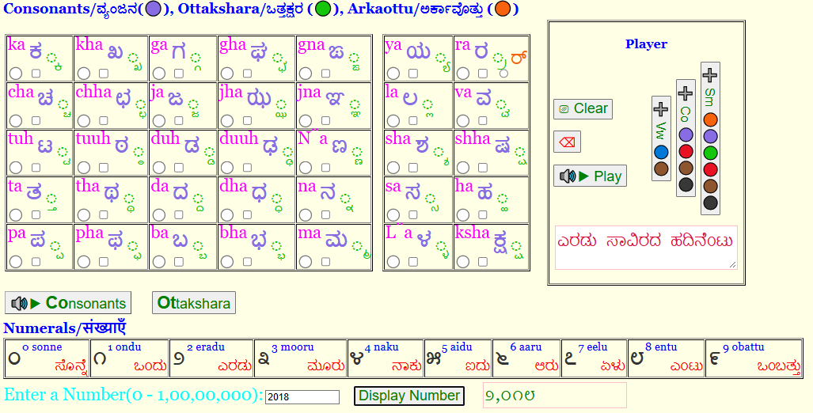

Troubleshooting and workarounds

Preloaded Sounds
Sometimes the Audio files don’t get loaded for streaming. In such cases, the Vowel or Consonants button background color becomes red as shown below.
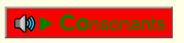
First make sure radio button selections are made to play sounds.
You can retry by clicking on the red button several times till it becomes green when reloading becoming successful.
If it still stays red, reload the page in the browser.
If it still stays red, you can continue and use player for sounds.

Sound Quality on Mobile devices
Due to CORS network restrictions, locally installed device voices are used instead of high-quality Google neural models. For the best sound quality and experience, please use a Desktop or Laptop if possible.

Reach out!
If you observe any inaccuracies or inconsistencies, kindly drop me an email at rvvyas@gmail.com with the subject starting with “aikannadatutor”.

